**Write a C program to implement Array operations such as Insert, Delete and Display.**

**INPUT:**

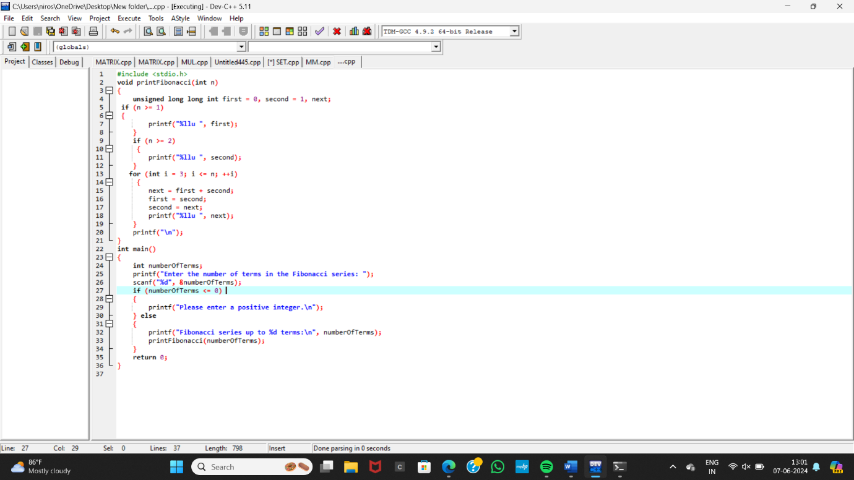

**OUTPUT:**

